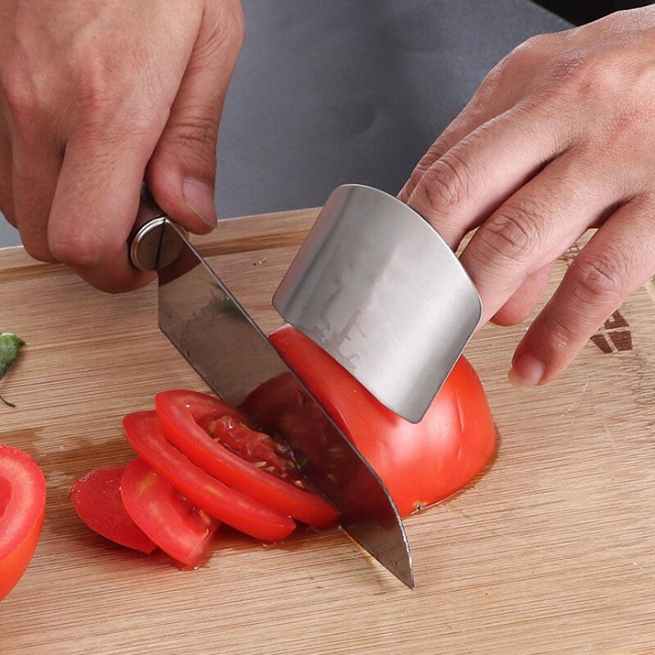
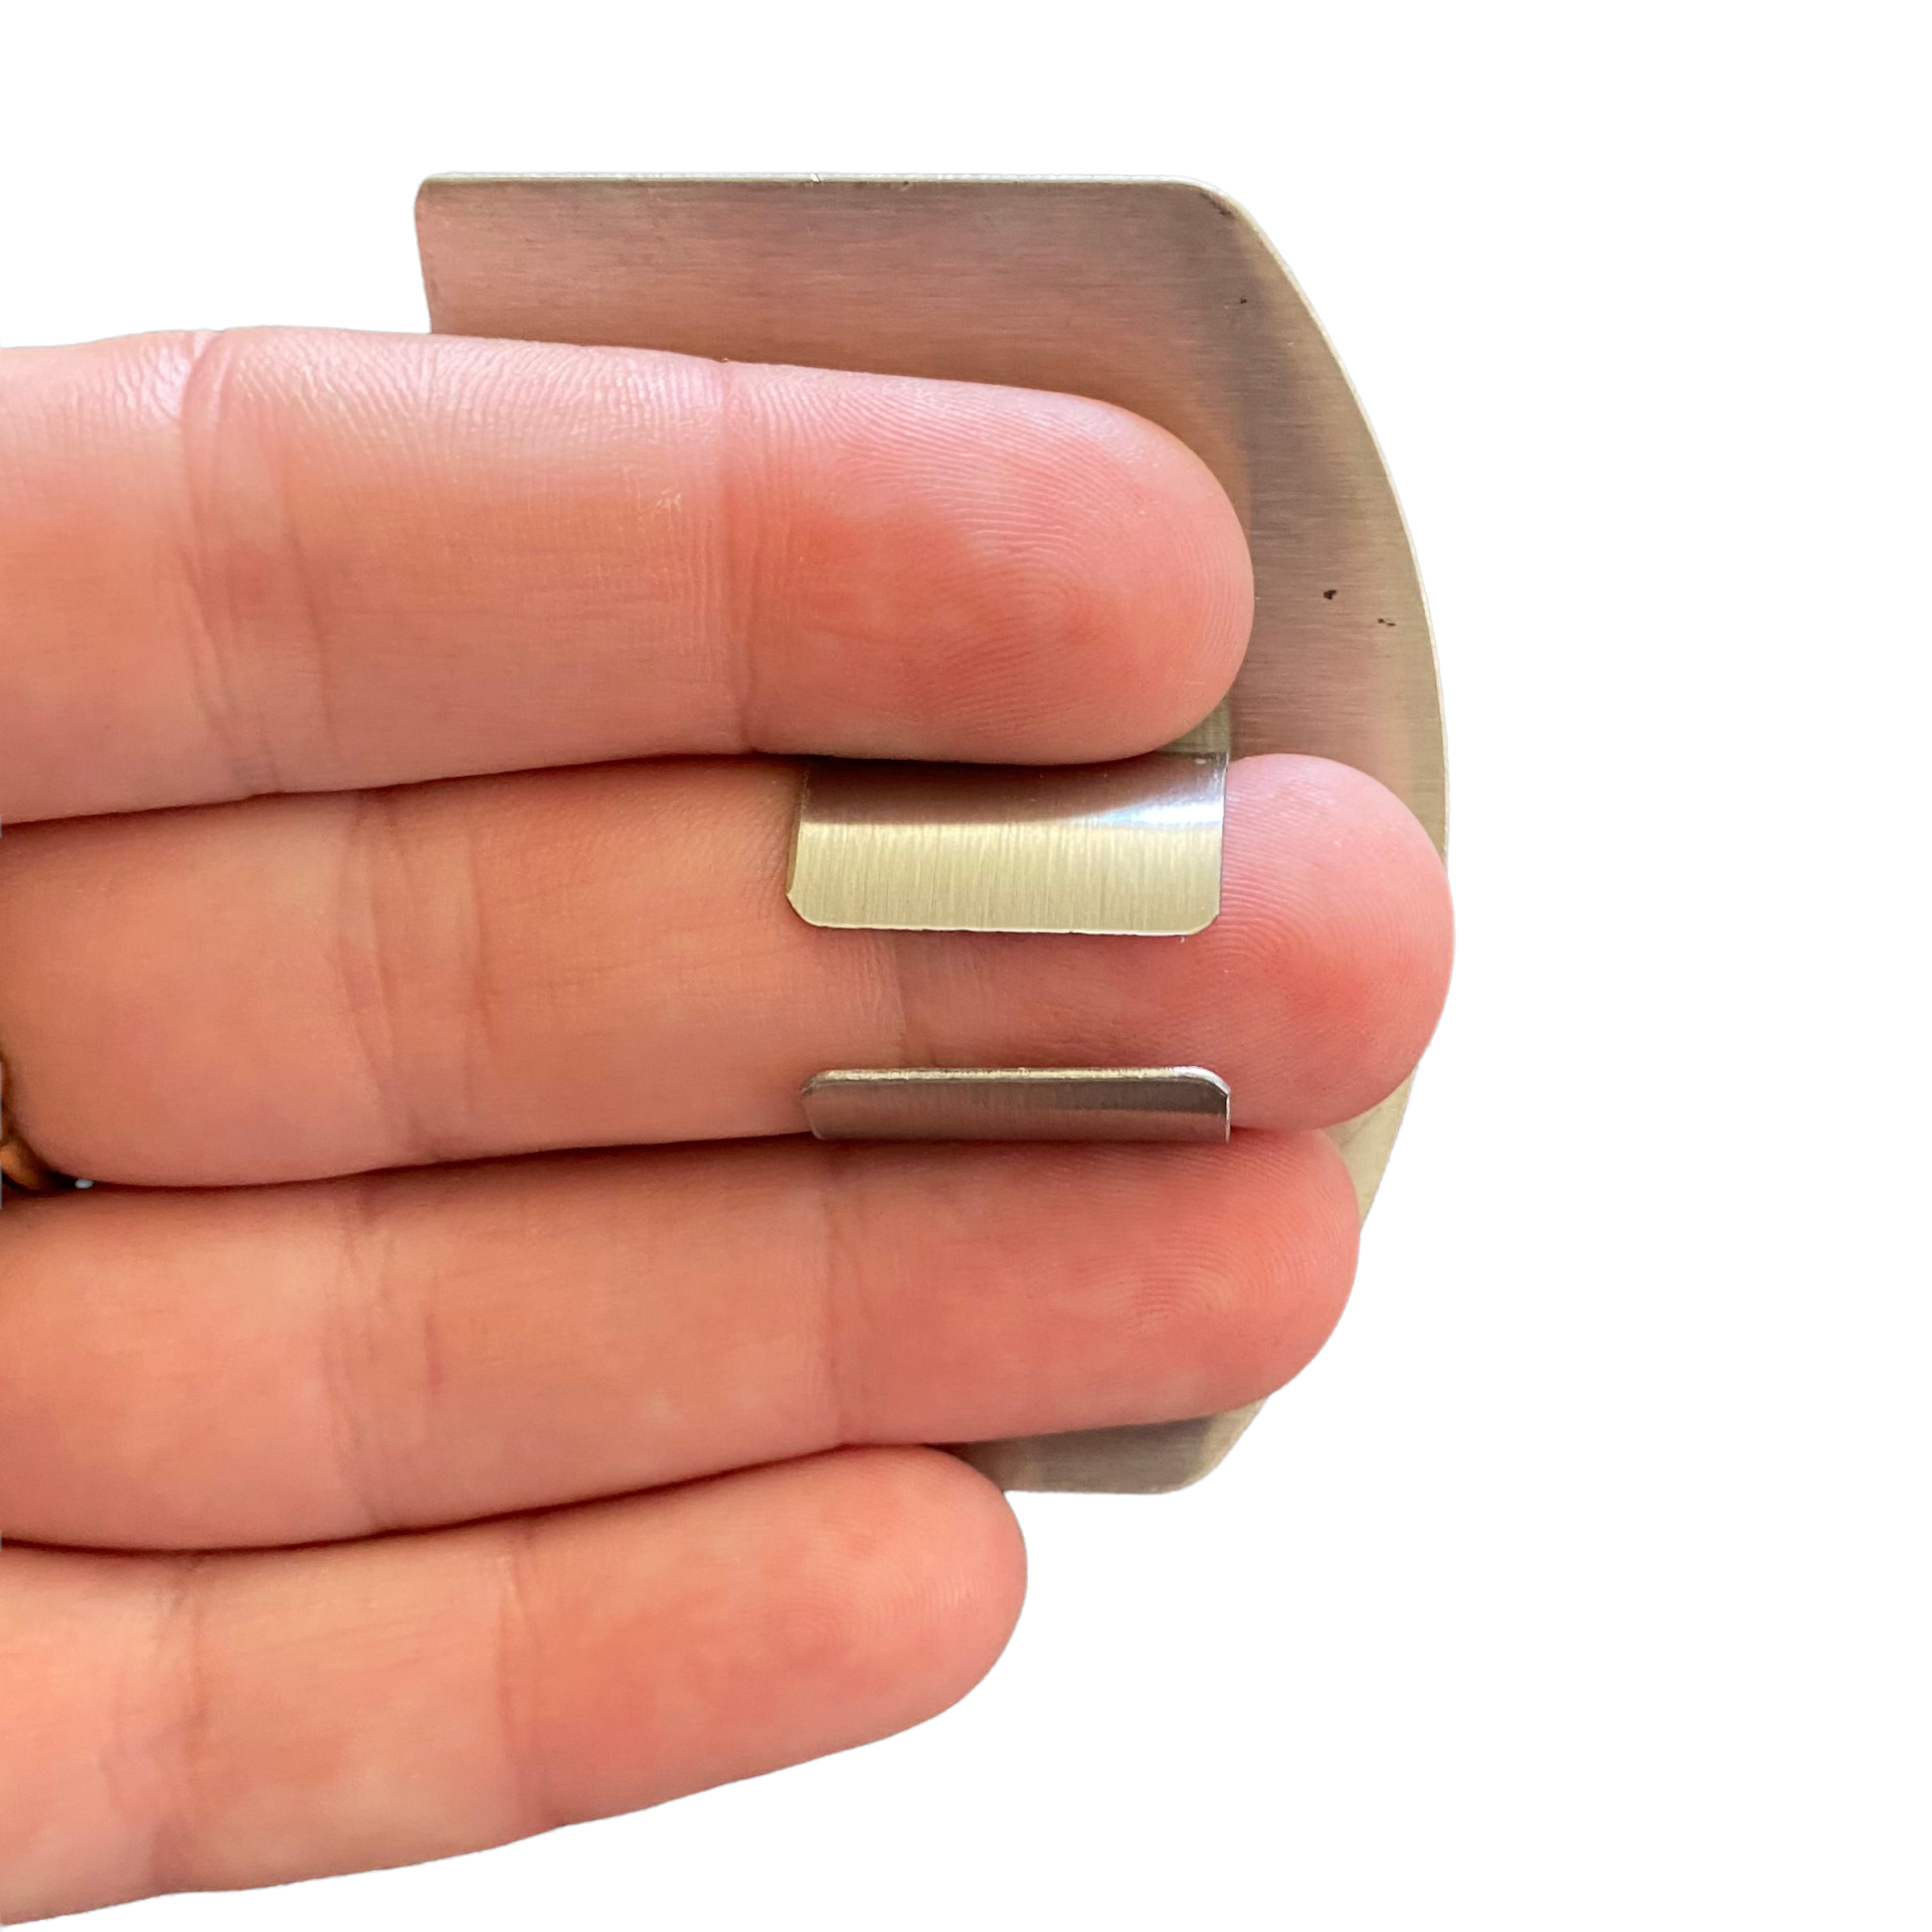
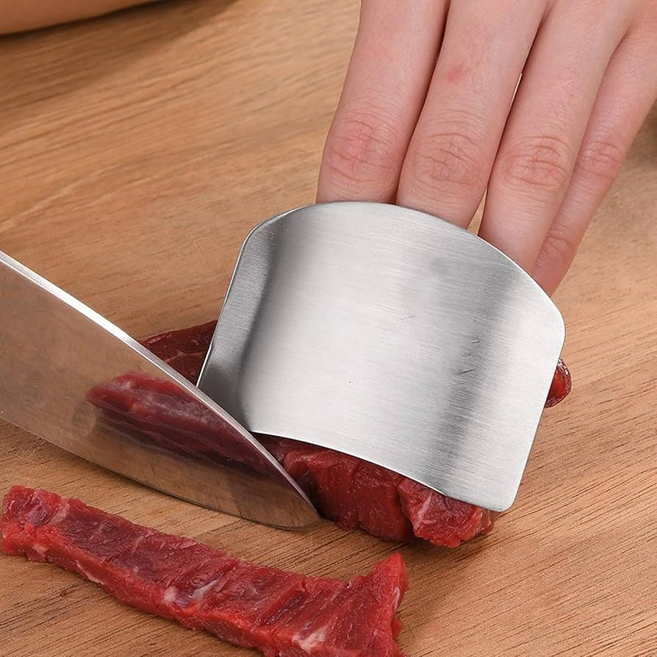
  - FOOD PREP FINGER GUARD INSTRUCTIONS

Description:

Chopping vegetables, meats, and fruits is easier when you have something solid to cut against.
This finger guard sits over your fingers and gives your knife a steady edge to follow, while your fingertips and knuckles stay tucked safely behind it. With that edge there, you’re able to hold and stabilise what you’re cutting more naturally, so your hand stays in place and the movement feels more controlled and consistent as you go.
It takes away a lot of the small adjustments and second guessing, making it easier to move through prep without overthinking it, and helps open up a more comfortable, supported way of chopping across different hands, kitchens, and stages of life.

Great for:
🥕 Everyday meal prep across vegetables, fruit, and meats
🔪 Creating more controlled, consistent slicing
✋ Protecting fingertips and knuckles while cutting
🖐️ Stabilising food while you chop
🧠 Learning and building confidence with knife skills
🧒 Kids learning safe knife use with supervision
👵 Maintaining independence in the kitchen over time
🧑‍🦽 Supporting a wide range of access needs
🏢 Workplace kitchens and health and safety practices
🍱 Batch cooking and prepping meals ahead
👨‍👩‍👧 Cooking alongside whānau (family), and friends

Features:
🛡️ Stainless steel guard protects fingertips and knuckles
✋ Provides a steady edge for your knife to follow
🖐️ Helps keep fingers in a safe, consistent position
✨ Lightweight and easy to wear
🧩 Adjustable fit to suit different finger sizes

Details:
Materials: Stainless Steel
Size: 7cm (L) x 5cm (W) x 3cm (H)
Weight: 12 grams
Package includes: 1x Finger Guard
Age Guidance: Suitable for teens and adults. Suitable for children when used with supervision. Not a toy.

How to Use:
🖐️ Slide your fingers into the guard
🥕 Hold your food with your protected hand
🔪 Guide your knife along the edge of the guard
📍 Keep fingertips and knuckles tucked behind the shield

Care Instructions:
🧼 Wash with warm soapy water after use
💧 Dry thoroughly after cleaning
📦 Store safely with kitchen utensils

